# Lab 03 - Manage Azure resources by using Azure Resource Manager Templates

Made by Valeriy Manuilyk <3

## Task 1: Create an Azure Resource Manager template

1.Sign in to the ****Azure portal**** - https://portal.azure.com.

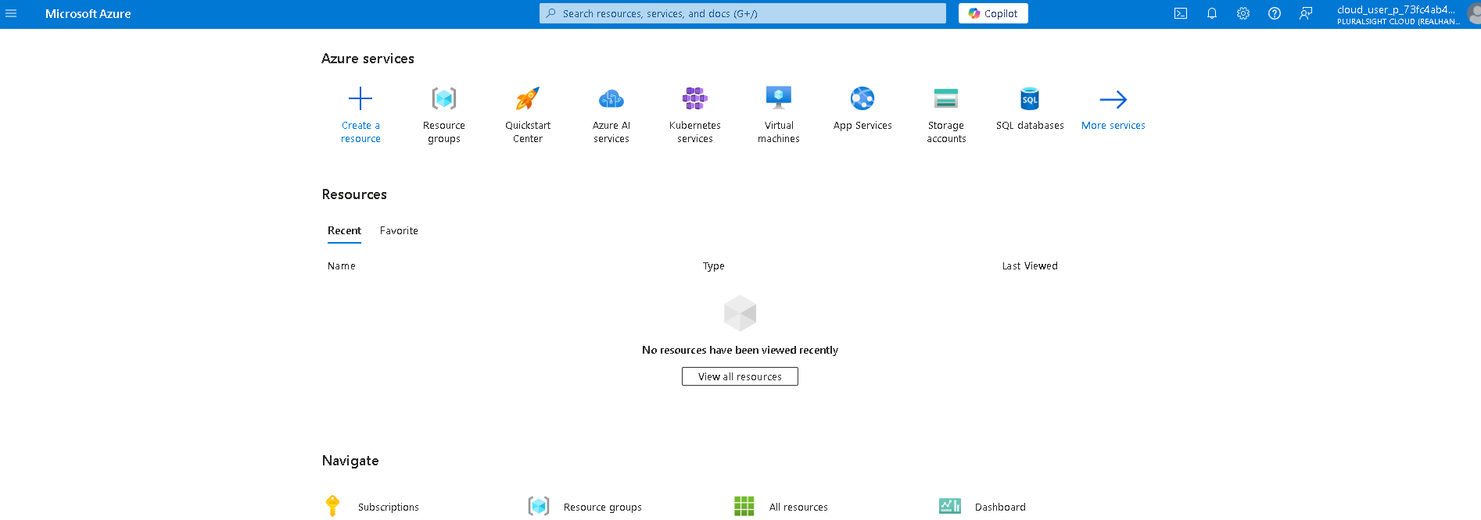

2.Search for and select Disks.

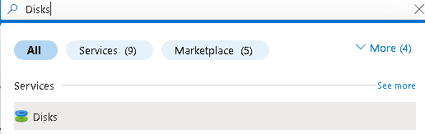

3.On the Disks page, select ****Create****.

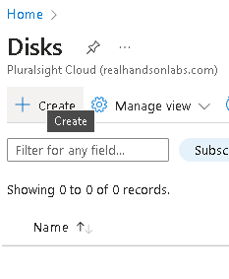

4.On the ****Create a managed disk**** page, configure the disk and then select ****Ok****.

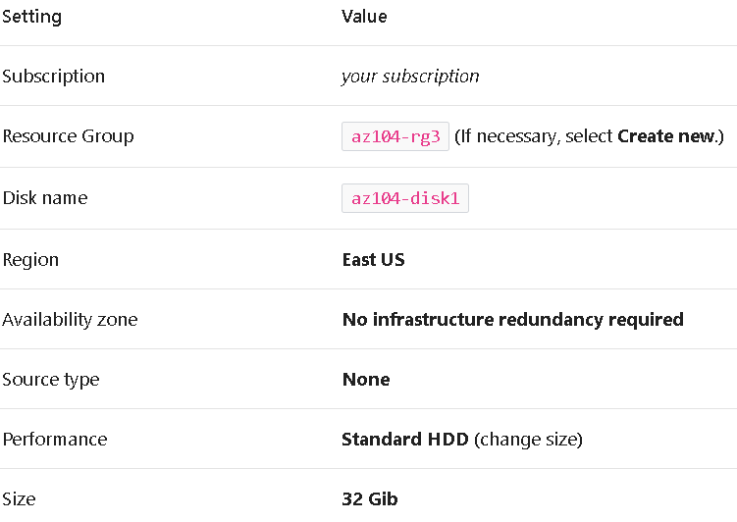

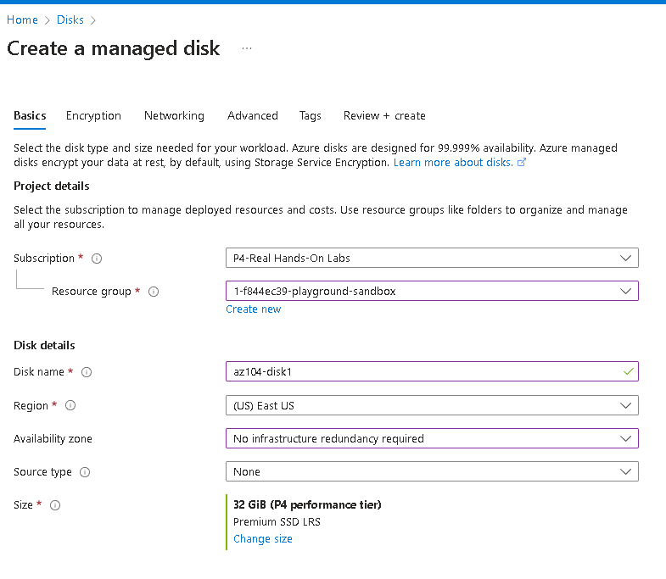

5.Click ****Review + Create**** then select ****Create****.



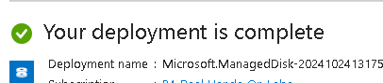

6.Monitor the notifications (upper right) and after the deployment select ****Go to resource****.

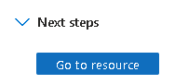

7.In the ****Automation**** blade, select ****Export template****.

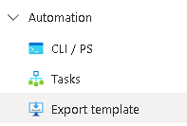

1. Take a minute to review the ****Template**** and ****Parameters**** files.

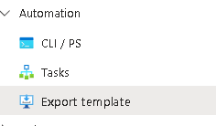

9.Click ****Download**** and save the templates to the local drive. This creates a compressed zipped file

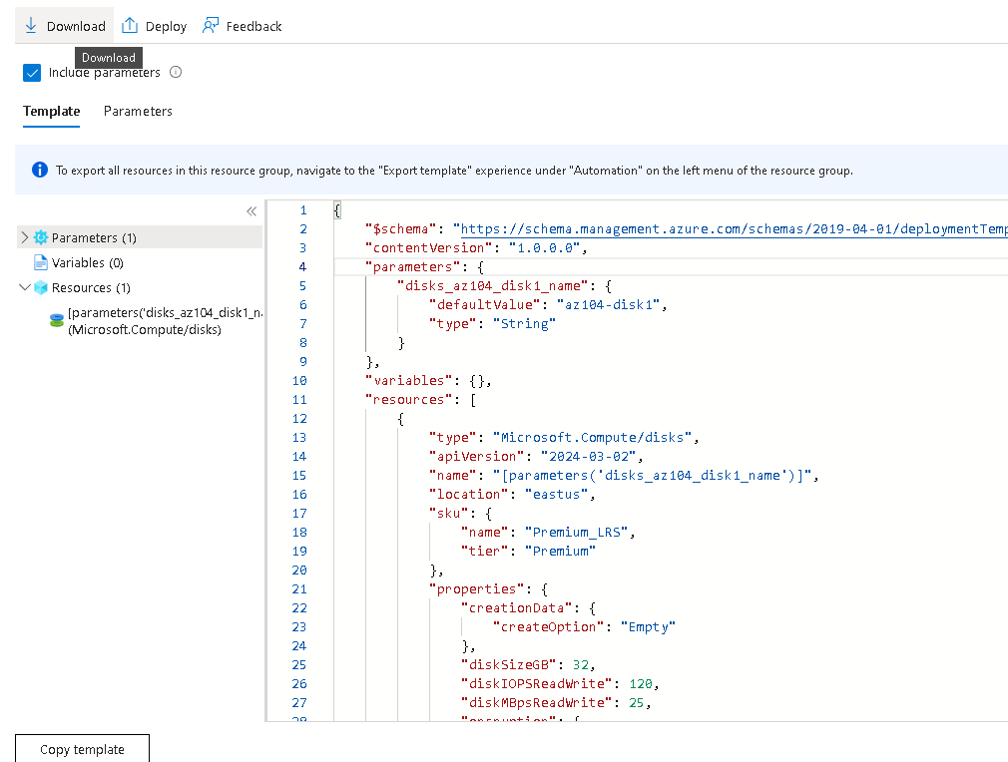

10.Use File Explorer to extract the content of the downloaded file into the ****Downloads**** folder on your computer. Notice there are two JSON files (template and parameters)

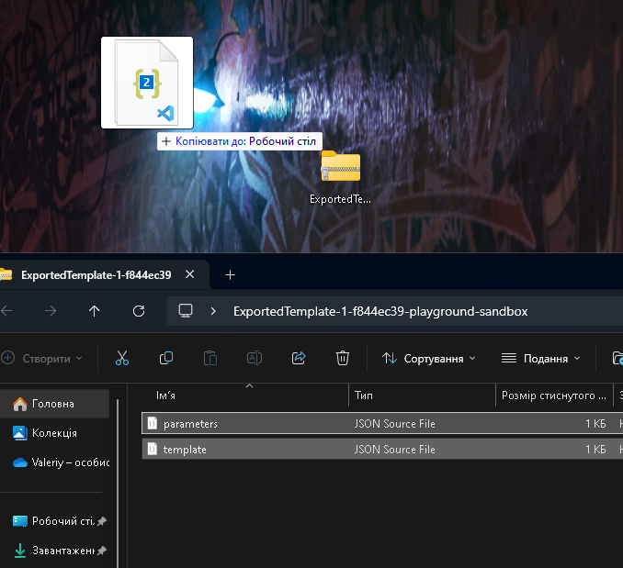

## Task 2: Edit an Azure Resource Manager template and then redeploy the template

1.In the Azure portal, search for and select Deploy a custom template.

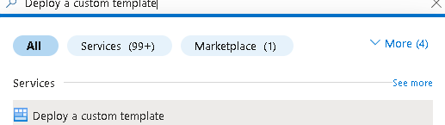

2.On the ****Custom deployment**** blade, notice there is the ability to use a ****Quickstart template****. There are many built-in templates as shown in the drop-down menu.

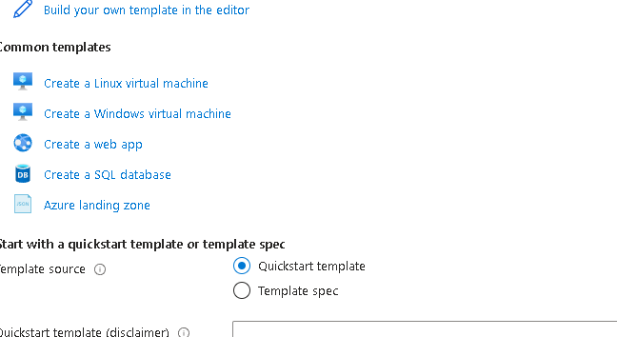

3.Instead of using a Quickstart, select ****Build your own template in the editor****.

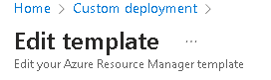

4.On the ****Edit template**** blade, click ****Load file**** and upload Wthe ****template.json**** file you downloaded to the local disk.

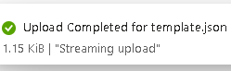

5.Within the editor pane, make these changes.

* Change ****disks_az104_disk1_name**** to disk_name (two places to change)
* Change ****az104-disk1**** to az104-disk2 (one place to change)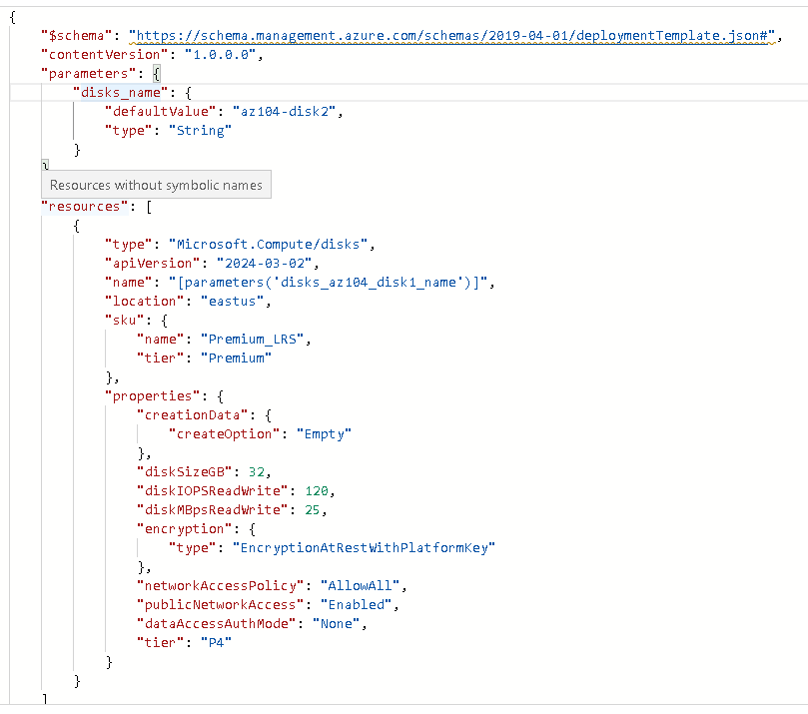W

6.Notice this is a ****Standard**** disk. The location is ****eastus****. The disk size is ****32GB****.

**7.**Save**** your changes.

8.Don’t forget the parameters file. Select ****Edit parameters****, click ****Load file**** and upload the ****parameters.json****.

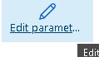



9.Make this change so it matches the template file.

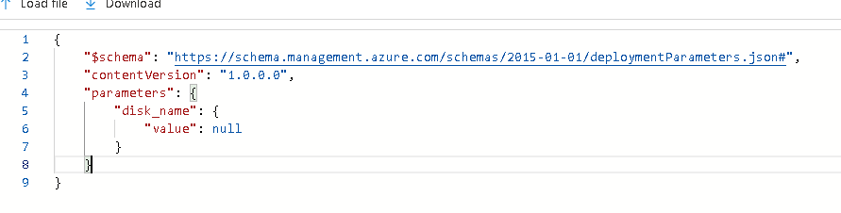

**10.**Save**** your changes.



11.Complete the custom deployment settings:

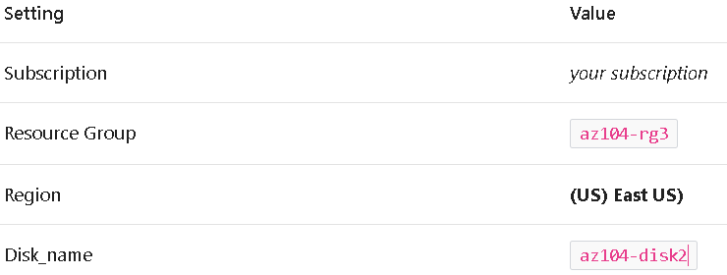

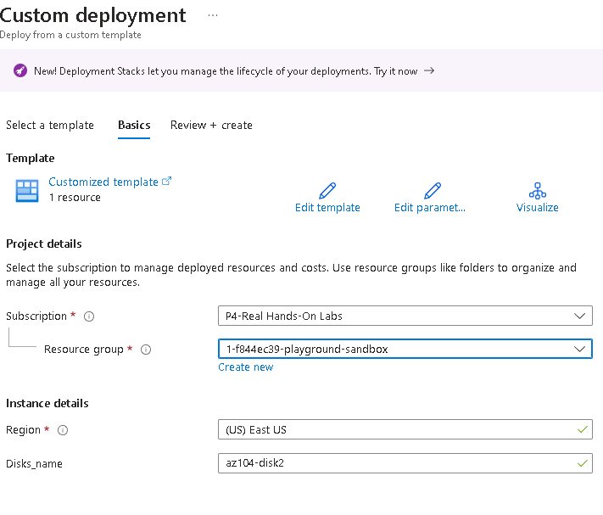

1. Select ****Review + Create**** and then select ****Create****.



1. Select ****Go to resource****. Verify ****az104-disk2**** was created.

14.On the ****Overview**** blade, select the resource group, ****az104-rg3****. You should now have two disks.

15.In the ****Settings**** section, click ****Deployments****.

16.Select a deployment and review the content of the ****Input**** and ****Template**** blades.

## Task 3: Configure the Cloud Shell and deploy a template with PowerShell

1.Select the ****Cloud Shell**** icon in the top right of the Azure Portal. Alternately, you can navigate directly to https://shell.azure.com.

2.When prompted to select either ****Bash**** or ****PowerShell****, select ****PowerShell****

3.On the ****Getting started**** screen select ****Mount storage account****, select your ****Storage account subscription****, and then select ****Apply****.

4.Select ****I want to create a storage account**** and then ****Next****. Complete the ****Create storage account**** information.

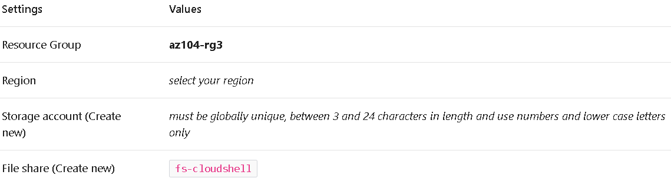

5.When completed select ****Create****.

6.Select ****Settings**** (top bar) and then ****Go to classic version****.

7.Select the ****Upload/Download files**** icon (top bar) and then select ****Upload****.

8.Upload both the template and parameters files from the ****Downloads**** directory.

9.Select the ****Editor (curly brackets)**** icon and navigate to the template JSON file on the left in the navigation pane.

10.Make a change. For example, change the disk name to ****az104-disk3****. Use ****Ctrl +S**** to save your changes.

11.To deploy to a resource group, use ****New-AzResourceGroupDeployment****.

12.Ensure the command completes and the ProvisioningState is ****Succeeded****.

13.Confirm the disk was created.

## Task 4: Deploy a template with the CLI

1.Continue in the ****Cloud Shell**** select ****Bash****. ****Confirm**** your choice.

2.Verify your files are available in the Cloud Shell storage. If you completed the previous task your template files should be available.

3.Select the ****Editor**** (curly brackets) icon and navigate to the template JSON file.

4.Make a change. For example, change the disk name to ****az104-disk4****. Use ****Ctrl +S**** to save your changes.

5.To deploy to a resource group, use ****az deployment group create****.

6.Ensure the command completes and the ProvisioningState is ****Succeeded****.

7.Confirm the disk was created.

## Task 5: Deploy a resource by using Azure Bicep

1.Continue working in the ****Cloud Shell**** in a ****Bash**** session.

2.Locate and download the ****\Allfiles\Lab03\azuredeploydisk.bicep**** file

**3.**Upload**** the bicep file to the Cloud Shell.

4.Select the ****Editor**** (curly brackets) icon and navigate to the file.

5.Take a minute to read through the bicep template file. Notice how the disk resource is defined.

6.Make the following changes:

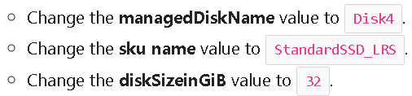

7.Use ****Ctrl +S**** to save your changes.

8.Now, deploy the template.

9.Confirm the disk was created.